Name____________________________________

Convection Currents Worksheet
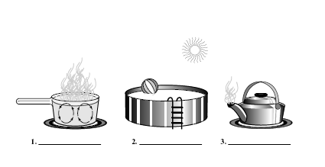
Label each figure by writing the type of heat transfer it shows.

4) How is heat transferred through space?

5) In general, what happens to the density of a fluid as it becomes hotter?

6) What are convection currents?

7) Name two layers of Earth in which convection currents take place.

8) What will happen to the convection currents in the mantle if Earth’s interior eventually cools down?

Match the definition to the word.
- the movement of energy from a warmer object to a cooler object
- the transfer of heat by movements of a heated fluid
- the transfer of energy through empty space
- the amount of mass in a given space (mass per unit of volume)
- the transfer of heat by direct contact of particles of matter
_____ 9) Radiation

_____ 10) Conduction

_____ 11) Convection

_____ 12) Density

_____ 13) Heat Transfer

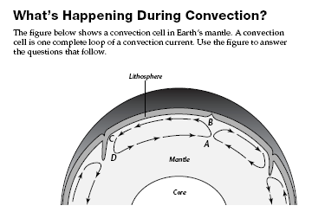

1) Where does the heat come from that drives this convection current in the mantle?

2) Where is the temperature of the mantle material greater, at point A or B? Explain why.

3) Where is the density of the material greater, at point B or C? Explain why.

4) What causes the convection cell to turn to the left at point B?

5) What happens to the temperature and density of the material between points B and C?

6) What force causes the convection cell to turn down at point C?

7) What happens to the temperature and density of the material between points D and A?

8) What causes the convection cell to turn up at point A?

9) Ho w do you think this convection cell might affect the crust material above it?

